**Labaratory Work 9**

**Student:** Adil Zhexenov

**Group:** SE-2101

First of all, I created a new database, which called ‘lab9’.



Then, I imported file ‘cricket_players.csv’ to this db:

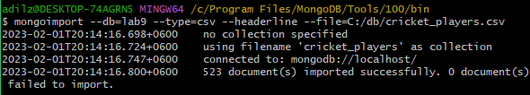

Task 1) Suppose there is a dearth in willow production this year and the bat manufacturer can only supply bats for either right-handed or left-handed batsmen but not both. Write a query for the bat manufacturer that groups the players by batting hand so that you can inform him which kind of bat he should put into production to gain maximum revenue.

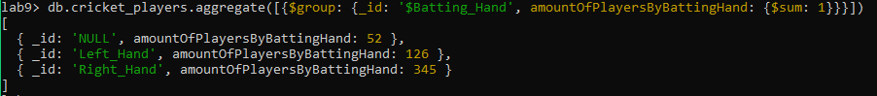

Task 2) There is talk of adding cricket to the Olympic sports. But before a conclusive decision can be made, the Olympic board needs to find out if its even feasible to do so. Write a query for the Olympic board informing them of the number of players in each country.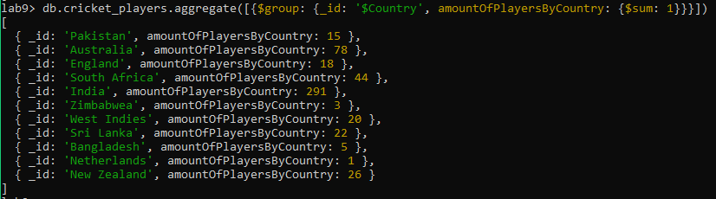

Task 3) The Olympic board is well aware of the willow crisis. Therefore, to be on the safe side, they have one more request for you. They would like to know the number of players of each country that bat with a given hand.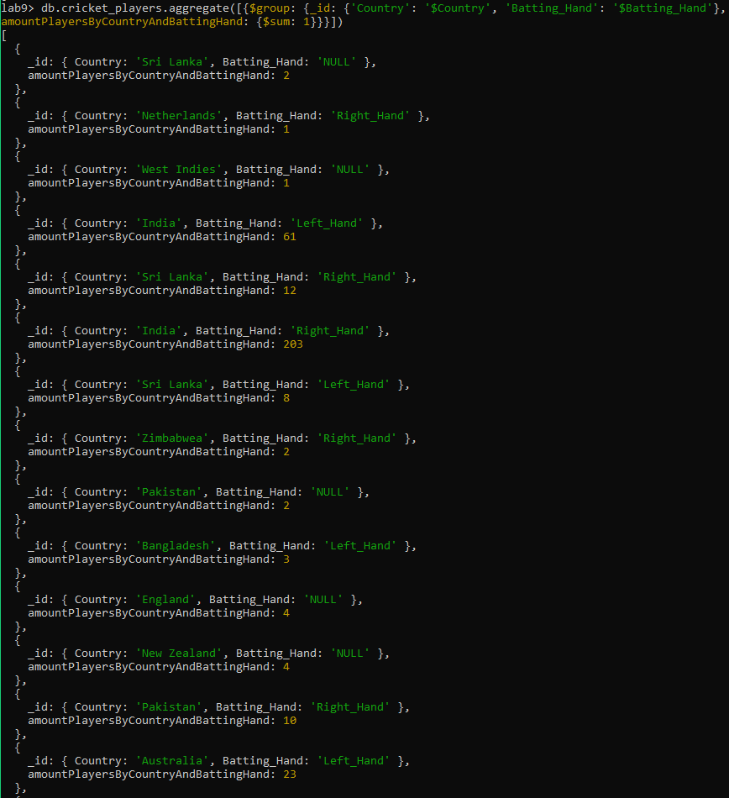

Task 4) We have observed NULL values in our previous results and even though it's important for us as database engineers to know what data is missing, our end users like the bat manufacturer or the Olympic board can't really do much with the NULL values. Let's improve our queries then to exclude the NULL values when grouping the players by batting hand.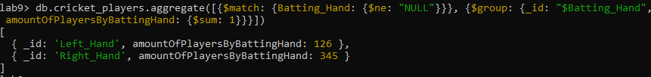

Task 5) Similar to Exercise 4, let's count the number of players by non null country

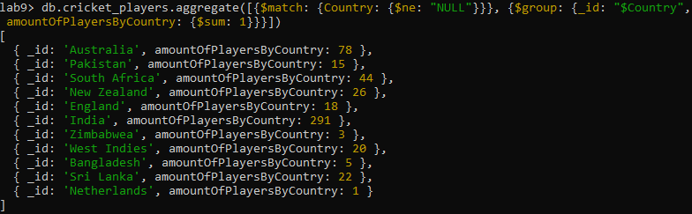

Task 6) One last thing we can do to ease readability for the Olympic board is to sort the players in alphabetical order in addition to all the changes we implemented previously. Put all your knowledge together and count number of players of each country that bat with a given hand. Remove null values of Batting_Hand and sort the output in alphabetical order

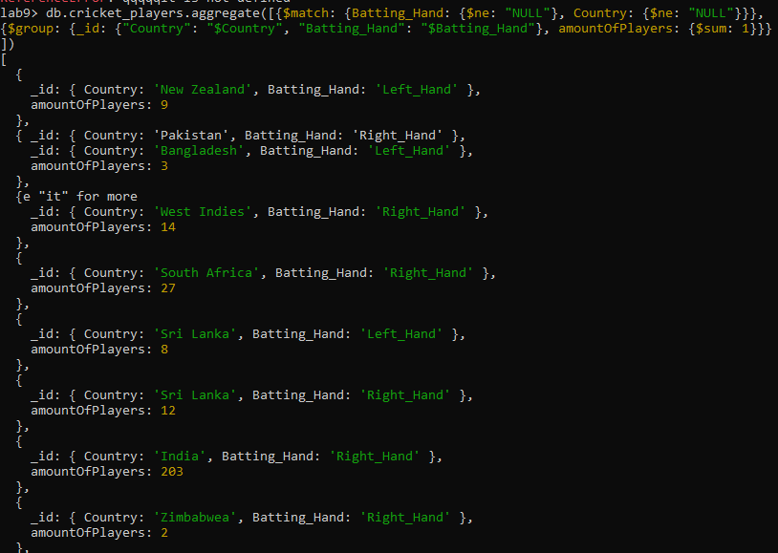

Before starting, I uploaded ‘employees_info.json’ to employees collection.

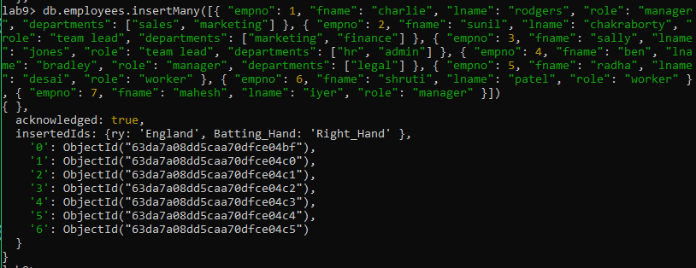

Task 7) Our employees are members of different departments. Deconstruct the departments array

such that there is a separate document for each department an employee belongs to.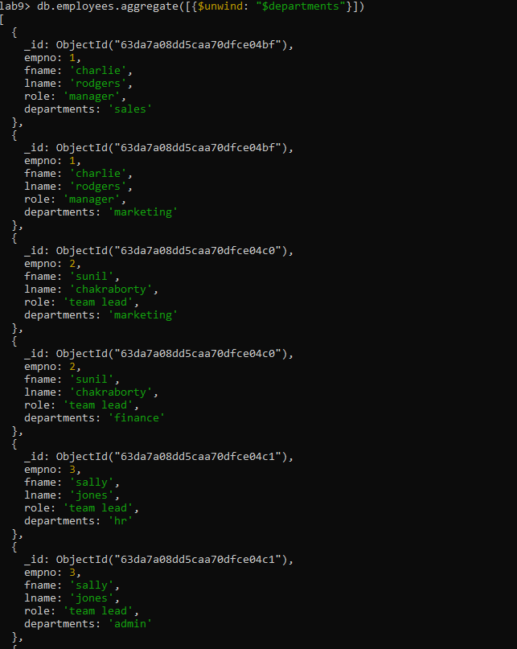

Task 8) In order to find an object's location in an array, include the index position.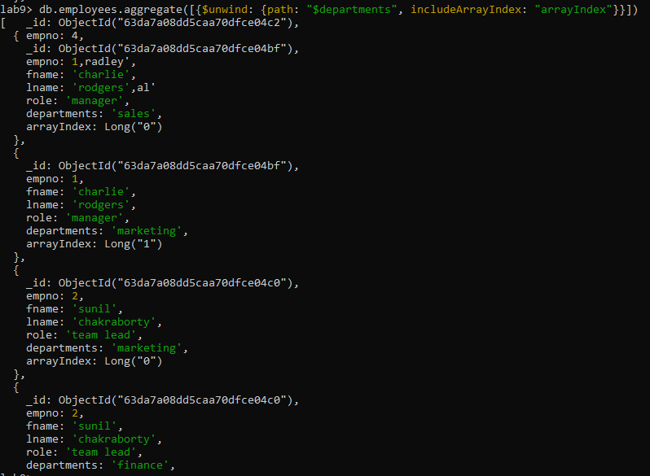

Task 9) Let's crunch some numbers! Count the number of departments an employee belongs to.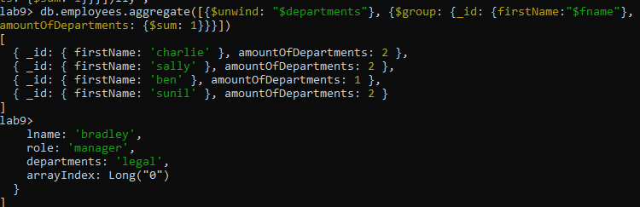

Task 10) Write a query that counts the number of employees in each department. To make things more interesting, perform this action only against employees having empno greater than or equal to 3

